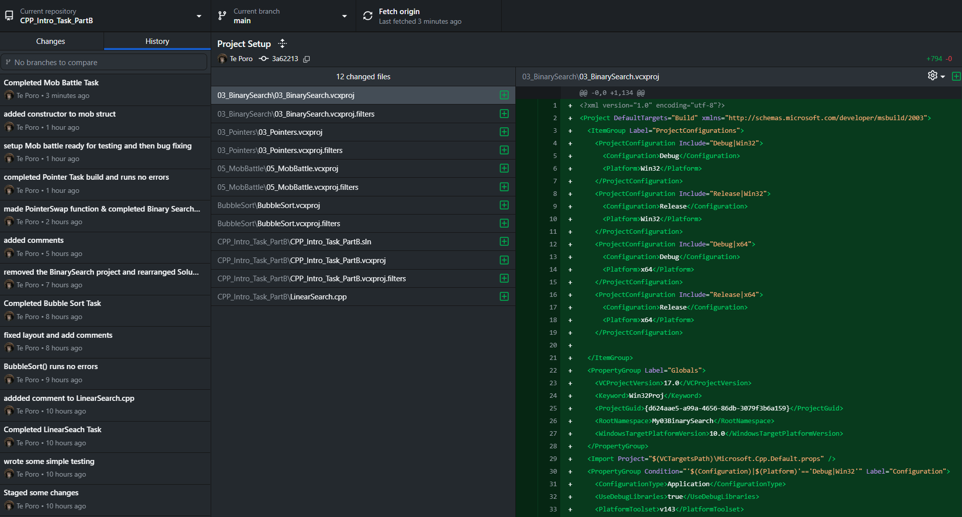

[Github](https://github.com/Tik4poe/CPP_Intro_Task_PartB)

